Lieldienas!

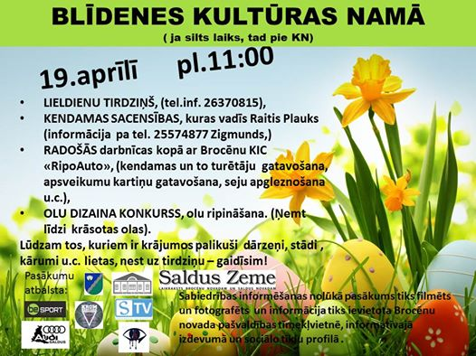

16

